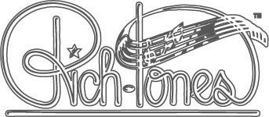

DESCRIPTION OF SPONSOR BENEFITS

Sponsor Recognition in Printed Program

A special section of the Fall Show Program is devoted to recognition and appreciation for all Rich-Tones sponsors. Your name will be featured prominently in the program section for your donor level.

One Year Website Ad with Link

Sponsors at $100 and up will be featured on our chorus website. For one year, your name (and a description of your business or service, if desired) will appear prominently under your donor level, along with a link to your website or a phone number of your choice.

Printed Ad in Fall Show Program

Sponsors at $200 and up receive a prominent ad. Submit your own, or allow our Rich-Tones design team to create one for you, incorporating information you provide.

Free Musical Greeting Cards

Sponsors at $200 and up receive Musical Greeting Cards(s) to the recipient(s) of their choice, performed by a quartet or Rich-Tones group at Christmas and Valentine’s Day.

Tickets to Rich-Tones Shows

Sponsors at $400 and above receive free tickets to Rich-Tones performances – enjoy our shows in person, or share your tickets with special clients to demonstrate your support of the Arts in the Dallas area. Our primary performances are:

- $400 and up – Fall Show at the Eisemann Performance Center, Richardson
- $1,000 and up – Fall Show at the Eisemann Performance Center, Richardson and
Casino Night tickets at the Elizabeth Ann Seton Center in Plano, TX (gaming, dinner, raffle, and silent auction)

Recognition from the Stage

Donors at $1,000 and up will be recognized as Corporate Sponsors during our Fall Show Performance.

